Faculty of Management Graduate & Placements Fair
Wednesday 18 November 2015, 11am – 3pm
Sponsored by Yummy Jobs
The Faculty of Management’s main annual event of the year inviting over 45 organisations within the sectors of Hospitality, Tourism, Retail, Business Studies with Pathways, Accounting & Finance, Sport, Events & Leisure. Organisations will be on campus to speak to you about their placement and graduate schemes.
This is a great opportunity to network with industry and get ahead with your career.
BaxterStorey
Beales Gourmet
Blue Arrow
Bourne Leisure - Haven
B&Q
Carnival UK
CH&Co Group
Chewton Glen Hotel & Spa
Corinthia Hotel London
Dixons Carphone
Firmdale Hotels
GE Aviation
Harbour Hotels
Harbour and Jones Events
Hilton Worldwide
House of Fraser
Hotelplan Ltd (Workaseason)
Kondor Ltd
Lime Blue Solutions
Lime Wood Group
Lucknam Park Hotel & Spa
Majestic Wine
Millbrook Venues
Mosimann’s
Parkdean
Park Plaza Hotels & Resorts
Pegasus Global Travel
Placement Year International
Place Rec USA Ltd
Planet Education (formally Planet Sport)
Q Hotels
SCL
Smyths Toys
The Appointment Group
The Grove
The Restaurant Group
The Savoy
This is Crowd
Thomas Cook
Traveltime Group
TUI Travel
UK International Soccer
Westover Group
WHSmith
Yummy Jobs

Website address: http://www.baxterstorey.co.uk/graduates
BaxterStorey is the UK’s leading independent food service specialist. Our heritage is built on the culinary expertise and the professional training and development of our teams.
We employ more than 7,000 people at over 600 locations, and provide food service excellence to our clients and customers in business and industry, names such as Aston Martin, RBS, ITV, ASOS.
BaxterStorey’s core principle is to serve the best quality food, sourced and prepared locally using the finest produce.
At BaxterStorey we ensure that all of our people are trained and motivated and ready to run their restaurants as if they were their own business. Through our dedicated, award winning in-house training academies, it provides our teams with focused, tailor- made training to our front line, helping them to become the best in their profession and to build a career for life.
Our highly successful Graduate Programme, Momentum, has seen more than 30 graduates build careers with us over the last 4 years, aiming for senior management roles within 5 years.
The reach and talent of BaxterStorey’s business enables it to draw on an extensive pool of expertise within the food service sector in the UK, providing us with a strong foundation to share and distribute best practice both locally and across the country.
Placement & Graduate opportunities available for students studying: Events Management & Retail Management

Beales Gourmet Ltd is a multi-award-winning event catering firm based at their exclusive venue, The Italian Villa at Compton Acres, Poole. The company, headed by celebrated hospitality expert, Tony Beales, has catered for some of the region’s most high profile events, including the Sandbanks Beach Polo Championships, the Dorset Business Awards and over 200 weddings per year at some of the South’s most prestigious venues.
Our back of house team comprises of talented, Michelin-trained chefs, who create gastronomic masterpieces for each and every event that we cater. They are equalled in excellence by our outstanding front of house team, all of whom have a precision eye for detail and an appetite for phenomenal customer service.
We are proud to have worked with Bournemouth University over the past 4 years in providing an exciting year-long placement to dedicated and energetic event management candidates. If you are looking to learn more about the events industry, and have a passion for food, people and outstanding customer service, we want to hear from you! Our team have gone on to win local, national and internationally coveted awards, and we expect the very best from our people. In return, you’ll enjoy some of the very best on-the-job training in the industry, and have the opportunity to work with our charismatic and friendly team, all striving towards the same goal – exquisite experiences for our customers.
Graduate and Placement opportunities for students studying Events Management.

Website address: www.bealesgourmet.com

Website address: www.gradatbhs.co.uk
We’re a department store that offers our customer modern lifestyle choices for the whole family. We’ve been trading on the British High Street since 1928 and our international business is going from strength to strength. We’re constantly investing in the brand, updating our product and introducing new concessions and concepts. Amongst many other projects, we’re in the process of opening a BHS Food Store in 20 of our sites around the country whilst giving the overall store a fresh new look. We really are a one stop shop with everything you need all under one roof. At BHS we are passionate about our people, their development and their future with our business and we pride ourselves in being a wonderful place to work! BHS is bigger, brighter and better than ever!
Graduate opportunities for students interested in Retail Management and Merchandising.

Website address: www.bluearrow.co.uk
Founded in 1959, Blue Arrow offers a knowledgeable recruitment solution to all your staffing requirements; adding value to your organisation. In our relationships with both local companies and national accounts, we focus our team and business processes towards the primary goal of delivering a recruitment solution to fit your business.
Graduate & Placement opportunities for students studying: International Hospitality Management, Events Management, Events & Leisure Marketing.

Website address: www.havenjobs.co.uk
We operate award-wining, family-focused caravan parks around the British coastline as part of the Bourne Leisure family. The 36 parks have an excess of 36,000 caravan pitches, making Bourne the largest operator of caravan parks in the UK. All our parks offer the opportunity to own a holiday home, and our owner’s services team’s looks after in excess of 23,500 holiday home owners. All of our guests come to our parks to enjoy a variety of activities and experiences from our entertainment and activities programmes to just wanting to escape from daily life and just spend quality and simple family time together.
Graduate & Placement opportunities for students studying: Events Management, Events & Leisure Marketing, Retail Management, Tourism Management & Sports Management including Golf.

With over 300 stores in the UK and Ireland and our Store Support Office in Southampton, we’re a local employer for many. Part of the Kingfisher Plc, Europe’s leading DIY Home Improvement retailer, the group employs over 78,000 people worldwide and has an annual revenue of over £10 billion. We’re committed to putting our people at the heart of our business and are proud that we were the first retailer in the world to win the Gallup worldwide award for outstanding Employee Engagement, picking up the award for five consecutive years. We know that Corporate Social Responsibility is important to you and that you’ll want to know we are doing business responsibly and safeguarding the resources of our planet for the future. In 2007, B&Q committed to become a One Planet business and to help our customers achieve One Planet Homes. This commitment encompasses policies for sustainability in our approach to carbon, waste, water and timber to name a few. We have since been honoured with the UK’s most prestigious business award, the Queens Award, for our work in creating a more sustainable business and helping people improve the sustainability of their homes.
Placement, Graduate & Part Time opportunities for students studying Retail Management

Website address: http://www.diy.com/corporate/careers/

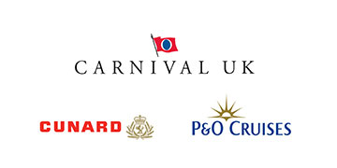
Carnival UK is the UK operating company for P&O Cruises & Cunard. We provide world class cruise holidays and operate a winning culture to achieve unrivalled success.
Cunard epitomises luxury on a grand scale with three iconic ocean liners including the world famous flagship Queen Mary 2. In 2015 we mark our 175th anniversary with celebrations and special events taking place around the world.
With eight ships, eight attentive and friendly crews and an entire wondrous world to explore, P&O Cruises is Britain’s cruise line of choice. Britannia – our brand new flagship – arrived in March 2015 giving us the opportunity to surprise, indulge and treat our passengers with more “this is the life” moments.
It takes great passion and real commitment to maintain our position at the top. That’s why exceptional, passionate people are at the heart of our journey delivering the highest standards to our valued customers. With support to help you reach your potential, attractive company benefits and incredible employee offers on discounted cruises we want your career with us to be a successful and enjoyable one. This is your chance to join us on our journey.
Graduate opportunities for students studying: International Hospitality Management, Events Management, Events & Leisure Management, Retail Management, Tourism Management, Sports Management including Golf, Sport Psychology & Coaching Sciences

Website address: http://www.carnivalukcareers.co.uk/index.html

Website address: http://careers.chandco.net/
CH&Co and its brand divisions are one of the most respected and vibrant, cutting edge companies within the food service sector today. We have a reputation for good food, unrivalled service and a passion for making each and every eating experience a memorable one.
We take an incredible amount of pride in our team, focusing on recruiting, developing and encouraging creative talent and the exchange of ideas.
We link development to training by offering opportunities such as; Skills workshops, ‘Back to front training’ for chefs who want to enter Management and Future Club’s for Managers who wish to climb the ladder.
Our values and commitment to the investment in our people has been recognised. In 2011 we entered the top 1.2% of company’s across all industries by being awarded the highest accolade available within Investors in People program of ‘IIP Gold Champion status’.
As we always say, ‘Good food starts with good people’!
Placement opportunities for students studying: International Hospitality Management, Events Management, Events & Leisure Marketing and Tourism Management.

Website address: http://www.chewtonglen.com/hotel/contact-the-hotel/hotel-careers.aspx
Chewton Glen Hotel & Spa is a luxury 5 red star property providing the highest service to our guests and are committed to consistently exceeding expectations
Placement & Graduate opportunities for students studying International Hospitality Management

Corinthia Hotel London combines contemporary flair with traditional grandeur. Situated in the cultural heart of the capital, the hotel features 294 beautifully appointed bedrooms, including 7 penthouses and 36 suites, with elegant restaurants and bars and the largest, most breathtaking spa in London.
London’s most exciting luxury 5* hotel opened its doors in spring 2011 and offers exceptional opportunities for individuals who are professional craftspeople in their chosen career. Providing individual service with precision and empathy for our guests you will be the heart and soul of this iconic 21st Century Grand Hotel. Our culture is strong, vibrant and distinctive.
Graduate & Placement opportunities for students studying International Hospitality Management
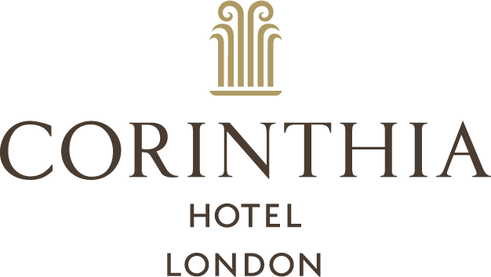

Website address: http://www.corinthia.com/about-corinthia/careers/

Website address: http://www.dixonscarphone.com/careers/overview
Carphone Warehouse have joined forces with Dixons Retail in the largest UK retail merger in history. Dixons Carphone launched on August 7th 2014. Overnight, we became one of the biggest retailers on the Stock Exchange. We now have 40,000 amazing colleagues, serving around 50 million customers in 2,900 stores across Europe. Now we are market leaders and have lots more opportunities for growth. As the world of technology becomes increasingly complex, our customers want greater choice, enhanced services and more expert help.
Graduate opportunities available in a variety of areas.

Website address: https://www.firmdalehotels.com/b/firmdale-careers/
"Hotels should be living things not stuffy institutions" maintain Tim and Kit Kemp, owners of Firmdale Hotels. There are eight boutique hotels in London and one in New York. The high standards of excellence and unique townhouse style of decoration have over the years added up to a winning combination. Kit Kemp has designed the interiors of each hotel in her unique personal way which reflects a fresh, modern English style. She was named the Andrew Martin International Interior Designer of the Year in 2008 and has gone onto win many more accolades. Firmdale Hotels has received the Queens Award for Enterprise in 2000, 2006 and 2009, recognition of its outstanding achievement to international trade. A further hotel is currently planned for New York.
Graduate opportunities for students studying: International Hospitality Management, Events Management, Events & Leisure Marketing & Tourism Management.
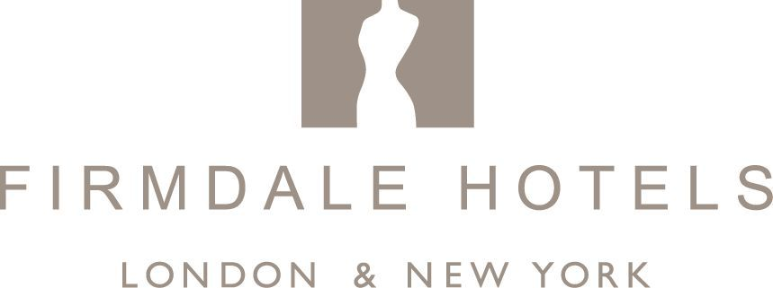

GE (NYSE: GE) imagines things others don’t, builds things others can’t and delivers outcomes that make the world work better. GE brings together the physical and digital worlds in ways no other company can. In its labs and factories and on the ground with customers, GE is inventing the next industrial era to move, power, build and cure the world.
Placement opportunities for students studying: Business Studies with Pathways, PR and Communications

Website address: http://www.ge.com/careers

Website address: http://www.golfbreaks.com/jobs
Golfbreaks.com was formed in 1998 by Chief Executive, Andrew Stanley, and is Europe’s specialist golf travel company, organising golf breaks for more than 200,000 golfers each year at over 2,000 resorts and courses in the UK, Europe and Worldwide. A further 15,000 customers use the group’s services to book spa breaks and spa days.
With more than 17 years’ experience and an expert team that is passionate about golf, spa and travel, we are known for delivering outstanding service and value, with the reassurance and security of booking with an ABTA and ATOL-bonded travel company. We are also the only golf travel company to reward customers for their loyalty through our Breakpoints customer rewards programme, which earns money off all future bookings made.
We have 150 staff based at our head office in Windsor, Berkshire – we also have offices in Charleston, South Carolina and Copenhagen, Denmark, from which our American and Scandinavian operations are run. We pride ourselves on our commitment to developing our employees and have been accredited with Investors in People since 2006. In July 2012 were awarded the Investors in People Gold Standard.
Graduate & Placement opportunities available in a variety of areas.

Website address: http://www.harbourhotels.co.uk/careers/
Harbour Hotels is a collection of prestigious hotels nestled in some of the most beautiful locations throughout the South. They include sensational waterside locations with stunning views at Sidmouth, Salcombe, St Ives and Christchurch and a boutique town house hotel in the centre of Christchurch.
Wake up to panoramic views across the water, enjoy fresh, local, seasonal food and drift away into coastal serenity, with a Harbour Hotels stay. From unrivalled coastal backdrops to award-winning dining experiences and indulgent Harbour Spas, guests can enjoy spectacular locations and unforgettable experiences.
Graduate & Placement opportunities for students studying: International Hospitality Management, Events Management, Events & Leisure Marketing and Tourism Management.

Website address: http://www.harbourandjonesevents.com/
Harbour & Jones Events is a highly creative, event caterer and designer – working in some of London’s most prestigious and iconic venues including: St Paul’s Cathedral, Cutty Sark, Westminster Abbey, Science Museum, The O2, The Royal Society and many more.
Proud to be the current Event Magazine’s ‘Caterer of the Year’, we’re renowned in the industry for creating stunning food-led events for big brands and corporate clients. Our objective is to give catering a starring role at events with every element tailored to enhance the guest experience and the client’s brand.

Our team of highly-skilled, event chefs take inspiration from London’s vibrant food and restaurant scene as well as from around the world, making Harbour & Jones Events one to beat in terms of setting and reflecting trends.

For those looking to forge a career in events and with an interest in food, Harbour & Jones Events offers a creative, supportive environment in which to thrive.

Graduate & Placement opportunities for students studying: International Hospitality Management, Events Management and Events & Leisure Marketing.

Website address: http://jobs.hiltonworldwide.com/en/?cntry=united-kingdom
Hilton Worldwide is one of the largest hospitality companies in the world, and we're growing faster than ever. Our 96-year history as pioneers in the industry makes us the preferred venue for travellers, developers, partners, and team members alike. Please join us on our adventure as we discover a world of opportunity.
Graduate & Placement opportunities for students studying: International Hospitality Management, Events Management & Tourism Management.

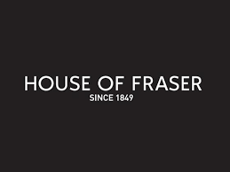
Hello, we're House of Fraser (fondly known by those who love us as 'HoF') and we've been on a mission to provide your heart's desires for more than 150 years.
From humble Drapery Shop in Victorian Glasgow to internationally inspirational department store, we've come a long way and we're still making history every day.
We're so much more than just a house; we're a whole universe full of your favourite things. Want to know more about how the magical walk-in wardrobe we call home came to be?
On the day we will be expecting to advertise Buying Assistant and Allocator placement year opportunities and graduate opportunities. At the moment our multichannel area is growing rapidly so we are always keen to speak with digitally aware candidates.
We will be advertising Store positions as well. If you share our passion for fashion, are full of personality and want to build your career with one of the fastest growing department stores in the world, join our friendly team and we’ll help you to grow, develop and progress in a retail environment that really is second to none.
Opportunities for students studying: Events Management and Retail Management

Website address: https://www.houseofcareers.co.uk/default.aspx

Hotelplan Ltd (Workaseason) is largest specialist independent skiing and walking holiday tour operator in the UK. Across our three brands (Inghams, Ski Total & Esprit Ski), plus our (Inghams Lakes and Mountains, Santa's Lapland and Esprit Sun programmes) we offer the widest range and variety of jobs in the Alps. With over 80 years of tour operating experience, we really are the experts!
All based in top class countries and resorts - so whether you are planning on doing just one season or a long term career in the travel industry, then we are most definitely the company for you.
Our jobs range from a wide range of Front of House staff including bar/restaurant staff, Chefs, Chalet Hosts, Hotel Management, Childcare and Resort Representatives.
If you are looking to live and work in the stunning environment of the mountains and are a versatile individual who thrives on delivering excellent customer service and are looking for a new exciting career opportunity then we can't wait to hear from you. All our jobs are listed on our dedicated recruitment portal site www.workaseason.com
Opportunities for students studying: International Hospitality Management, Events Management, Events & Leisure Marketing & Tourism Management.

Website address: http://kondor.co.uk/jobs/
Kondor is the UK’s leading distributor of consumer electronics, supplying a wide range of products to more than forty countries. We work with some of the world’s leading brands, including Beats, B&O, KitSound, and Samsung, as well as retailers such as EE, Tesco, and John Lewis. Our portfolio of accessories support smart phones, tablets, audio devices, and cameras. Kondor is proud to offer a full-service, in-house marketing agency, as well as advanced e-commerce systems and drop ship vending – alongside years of experience in channel integration and management.
Statistics:
- Kondor had an annual turnover in 2014 of £110 million.
- Kondor is proud to work with over 200 brands such as Skullcandy, Sennheiser, Nokia, Lexar, and Philips.
- Kondor is proud to work with over 300 retailers such as Amazon, Tesco, EE, British Airways, John Lewis, and Argos.
Graduate & Placement opportunities available in a variety of areas

Lime Blue Solutions, a fully independent agency offering a refreshing approach to worldwide event management, venue finding and incentive trips. We are an established company and have been successfully delivering events for our clients for over a decade. We are based in the heart of the Thames Valley, in Maidenhead, with excellent links to London and the surrounding areas.
We are a friendly team of experienced professionals all with solid backgrounds in running events of all sizes on an international level. We are passionate about what we do and committed to delivering exceptional levels of service to each and every one of our clients.
Placement opportunities for students studying: Events Management, Events & Leisure Marketing, Tourism Management & International Hospitality Management.

Website address: http://www.limebluesolutions.com/home.html

Website address: http://www.limewoodgroup.co.uk/
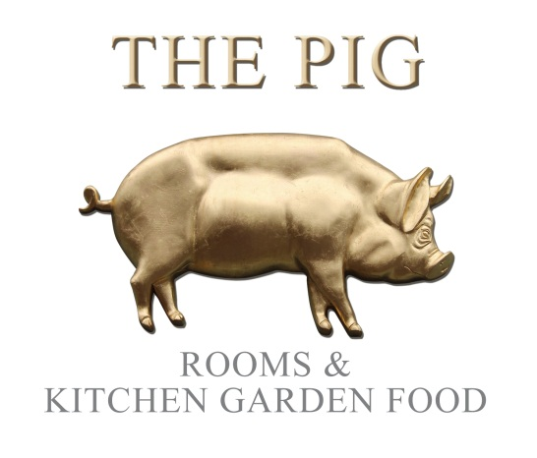
Home Grown Hotels is possibly the most talked-about group of hotels to emerge in recent years. THE PIG ‘restaurant, rooms and kitchen garden’ concept was created in 2011 and has quickly been showered with armfuls of industry awards.

The Lime Wood Group includes the much-applauded five-star flagship hotel Lime Wood, which probably sits within the top handful of today’s country house hotels. Equally, our stylish ski-in, ski-out hotel – Portetta in the French Alps at Courchevel 1650 – adds an exciting European dimension to our group.

“Our hotels are commercially highly successful and very busy, fun establishments. They are less formal than many, yet offer the highest levels of professional craft and personal service.
The fast pace of growth over five years has spawned countless opportunities for exciting careers, with many more in sight for the future. We need the brightest, most passionate people to help us achieve our goals – in joining us, we want to help you achieve yours”.
Robin Hutson, Chairman of Lime Wood and CEO of THE PIG hotels

Graduate & Placement opportunities for students studying: International Hospitality Management & Tourism Management.

Website address: https://www.lucknampark.co.uk/about/careers/
Lucknam Park is unspoilt, country house living at its very best and one of England's finest 5 star luxury Country House Hotels. We offer fine dining in The Park restaurant or a more relaxed meal in The Brasserie. We have extensive leisure facilities including a Spa, Equestrian Centre and Cookery School plus 500 acres of stunning parkland. Lucknam Park is a proud member of Relais & Châteaux and Pride of Britain and has been awarded a Michelin Star, AA 5 Red Stars and Visit Britain Gold Award.
Graduate & Placement opportunities for students studying International Hospitality Management and Tourism Management.
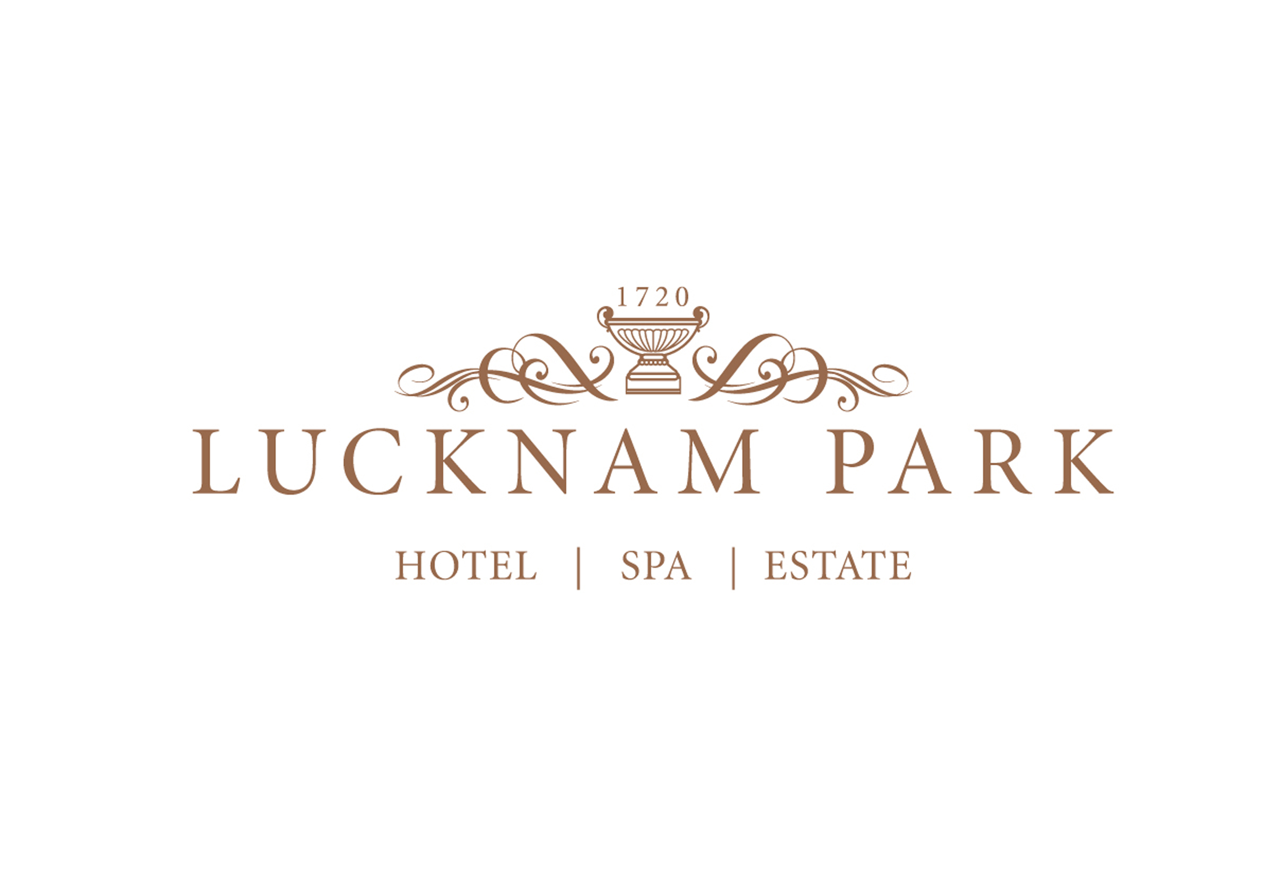

Majestic Wine is the UK’s largest wine retailer, specialising in selling mixed cases of wine. We pride ourselves on our enthusiastic, knowledgeable and friendly staff, who work as part of a close-knit team, delivering exceptional customer service.
Here at Majestic we offer a Retail Management Scheme as individual as you are. You don’t have to be a wine expert but an interest in learning about this exciting product will be required. We sponsor all of our staff through an industry recognised qualification WSET (Wine and Spirit Educational Trust) Level 3 certificate.
As a Trainee Manager you will be involved in all areas of running a store from merchandising and selling to making deliveries, so a driving licence is essential. At Majestic Wine Warehouses we are proud to promote our retail staff internally, allowing you to progress to Store Manager level within as little as three years.
We recruit throughout the year based on the needs of the business and as we are looking to open a number of new stores in 2015 there is no better time to join. Visit our website to find out our current vacancies, alternatively register your details and receive job alerts for future roles at Majestic Wine Warehouses.
Discipline: Any
Role: Trainee Manager
Number of vacancies in 2015: 340+
Location: Stores Nationwide
Website address: http://careers.majestic.co.uk/

Millbrook Proving Ground is one of Europe’s leading automotive prototype test & development centres. It is set in a site of around 700 acres with over 45 miles of specialist driving tracks & surfaces and is quite unique in having permanent Events facilities within this exciting environment. Millbrook is located just south of Milton Keynes.
Millbrook Venues exists as a separate brand within Millbrook Proving Ground, and is responsible for the delivery of a wide range of events for “Blue Chip” clients from all sectors of industry, most of whom are household names. These primarily take place here at Millbrook, where we have four unique venues giving us indoor capacity to run events for between 30 and 1,250 people, as well as utilising the outdoor space to run events for up to 5,000 people. These range from exhibitions & conferences to product launches, ride and drive promotions, themed evenings, parties, and track based activity days. A significant proportion of our events involve the use of Millbrook’s track facilities, either as a core element when dealing with our automotive clients, or to enhance events in other industry sectors.
Millbrook Venues has a team of Event Managers who work to deliver this wide range of events to our clients and the undergraduate Event Support position is part of this team of dynamic individuals.
Placement opportunities for Events Management Students

Website address: http://www.millbrookvenues.co.uk/about-millbrook/Careers

Mosimann’s private dining club in London was opened in 1988 by Anton Mosimann whose culinary philosophy “Passion for Excellence” has paved the way for exceedingly high standards within the Hospitality Industry. The Club has 7 private dining rooms for corporate entertaining and is registered for weddings. Mosimann’s received the Royal Warrant for Catering Services by appointment to HRH The Prince of Wales in 2000.
Graduate, Placement & Vacation opportunities for students studying: International Hospitality Management and Events Management

Website address: http://www.mosimann.com/

Parkdean was formed with the acquisition of Trecco Bay Holiday Park in November 1999. The Group has grown through a 'buy and build' strategy and now owns 24 holiday parks throughout the UK. Parkdean offers:
•A range of quality holiday homes, including caravans, lodges, cottages and apartments which are available for short breaks and longer holidays.
•Caravan and camping pitches.
•The choice to own your own holiday home, contemporary holiday home or lodge at 19 of our holiday parks.
Graduate & Placement opportunities for students studying: Tourism Management, Retail Management and Sports Development & Coaching Sciences
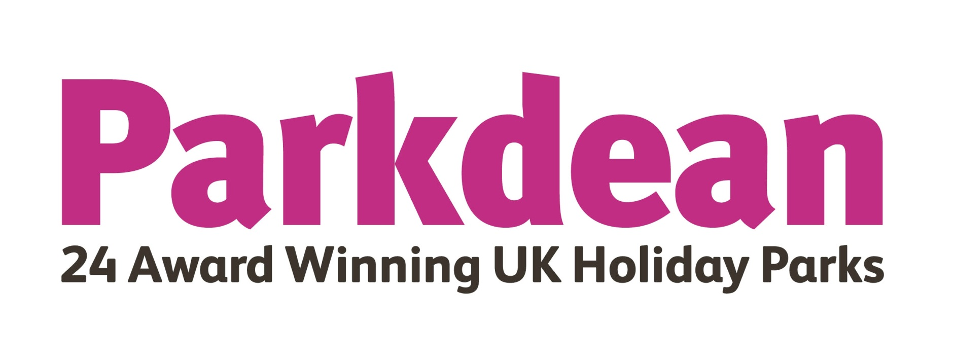

Website address: http://www.parkdeanltd.com/recruitment.htm

Website address: http://jobs.pphe.com/
As one of the world’s fastest-growing hotel brands, Park Plaza Hotels & Resorts boasts a choice of contemporary upscale hotels in key city centre locations and resort destinations around the world. We believe that what truly sets us apart is the quality of our smart, engaging service – our talented and motivated team members bring the Park Plaza brand alive by going out of their way to make our guests feel valued and appreciated.
One of the world’s fastest-growing hotel brands, Park Plaza is part of PPHE Hotel Group Limited, which owns leases, develops, operates and franchises full-service upscale and lifestyle hotels, predominantly in Europe.
Placement opportunities for students studying: International Hospitality Management, Events Management and Tourism Management
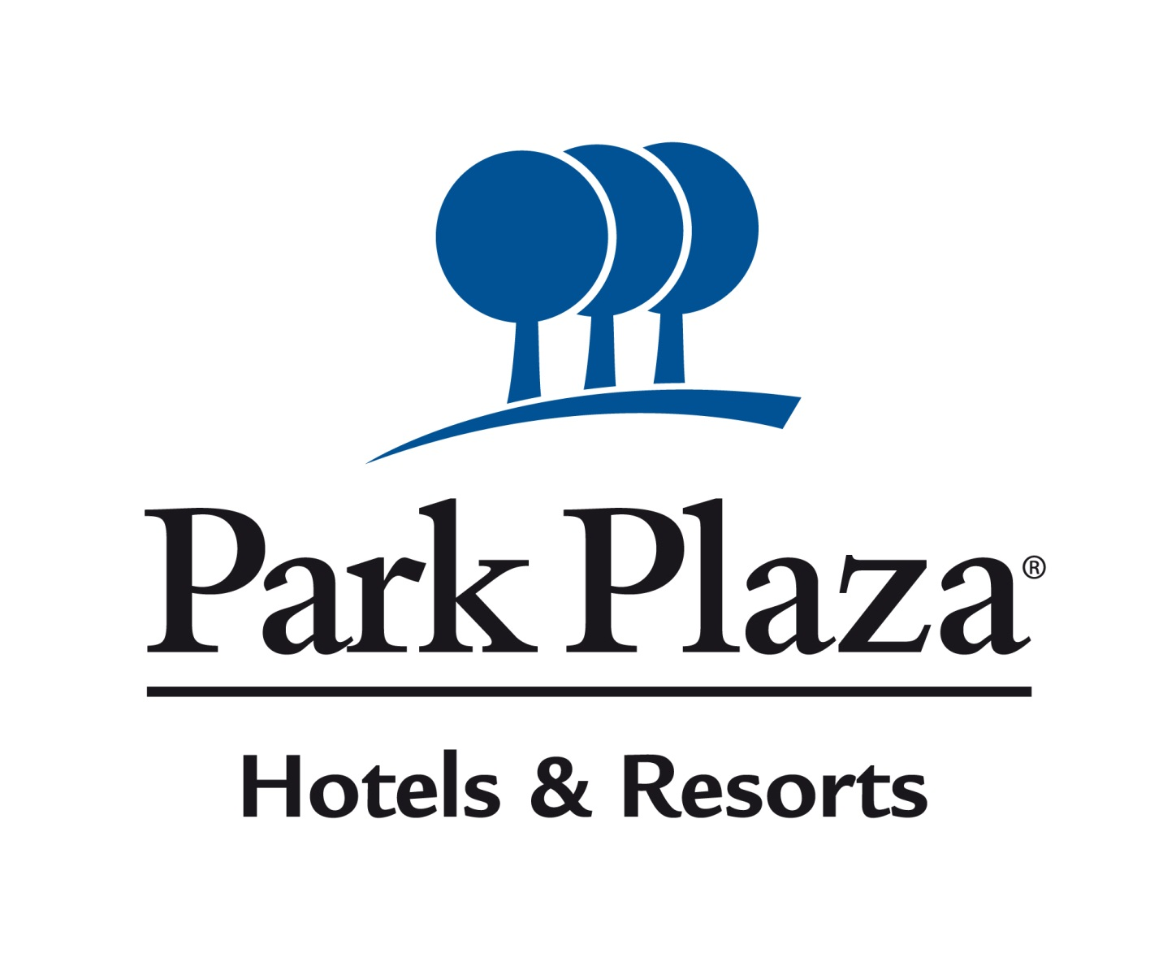

Pegasus Global Travel is one of the UK leading Travel Agency and Tour Operator which is mainly specialized in UK, Europe and China tours, air tickets and Visa with more than 4 year fast development since 2011. We also provide service of immigration inquiry for people are willing to become a Business Investor and Immigrant of the UK based in London, Pegasus Global Travel is a full-license sponsorship company, with IATA, ABTA and ATOL licenses.
Opportunities for students of any degree

Website address: http://www.ukpgt.com/

Website address: http://www.placement-year.org/
Paid hotel internship placements at 5 star hotels in Shanghai, China.
Fully supported worthwhile placements with global brand hotels and small boutique hotels.
Flexible start dates.
Flexible durations.
No fees charged.
Included:
- Salary
- Food
- Accommodation
- Airport transfers
- Orientation
- Phone card
- Visa documents
- Pre-departure placement & accommodation information
- 24/7 emergency support
Graduate, Placement and Vacation opportunities available for students studying: International Hospitality Management, Events Management, Events & Leisure Marketing, Tourism Management and International Business

Place Rec USA Ltd was set up in 2011, dealing with paid work placements in the hotel and resort industry of USA, New Zealand, Australia, Canada and Europe. These placements cover the following areas: Food and Beverage, Front Office, Recreation, Retail and Housekeeping. They can vary from 12 months to just summer work.
The USA placements are open to students and graduates studying Hospitality, Events, Retail, Tourism, Hotel Management, and Sports. General Business Courses are also possible as long as a university letter is received stating that it would be a suitable placement. I am in partnership with American Hospitality Academy and Janus International, who have the links with various hotels and theme parks.
Placements in New Zealand, Australia and Canada are open to all students and graduates aged 18-30 with relevant work experience.
Work experience at winter and summer resorts in Europe are for all students and graduates
Placements in Spain and Portugal are open to students, who possess intermediate level of Spanish or Portuguese.

Website address: www.placerechub.com

Planet Education (formally Planet Sport) offers schools and parents' high quality PE and Sports provision /extended schools services/ Active Ofsted registered childcare holiday courses as well as inspirational nursery programmes.
Our experienced and highly motivated management team have been successfully operating within the education and childcare sectors for well over a decade!
We sincerely hope that you will allow us an opportunity to demonstrate how we can make a difference at your school by supporting you in the up skilling of your teachers and by increasing each pupil's enjoyment of PE and Sport.
For parents, you can rest assured that the welfare of your child is our priority and by participating in one of our Active Ofsted registered courses, you will discover a perfect solution to your school holiday childcare needs.
Graduate & Placement opportunities for students studying: Sports Development & Coaching Sciences, Sports Management including Golf, Sports Psychology & Coaching Sciences.

Website address: https://www.planeteducation.co.uk/join-our-team/recruitment

QHotels is a group of 27 4 star hotels reaching all the way from Scotland to Kent. From leisure experiences, to business and events, QHotels provides bespoke 'Inspired By You' service in a range of different hotels. Placements are available throughout all of the hotels, in areas such as Food & Beverage, Front Office and generalist placements. Our placement programme allows guaranteed access on to our award winning graduate scheme, designed to develop and progress through the hospitality industry.
Graduate & Placement opportunities available.

Website address: http://www.qhotelsjobs.co.uk/

Website address: http://wearescl.co.uk/
Website address: http://www.scl-online.co.uk/workforscl.php

Established in 1999, SCL is a leading provider of Primary Services and Childcare in the South East of England. Services include the delivery of extra-curricular clubs in a variety of sports, National Curriculum PE lessons during curriculum hours, Breakfast Clubs, Holiday Camps, Saturday Soccer and Birthday Parties.
SCL is an exciting and dynamic place to work. We value the ideas and suggestions of our staff and look to them to help our business expand and become an even bigger name in education. Our aim is to help improve education through sport and deliver a range of high-quality extended childcare services.
So, if you feel you can help us to achieve that, then please don’t hesitate in applying to us……you won’t regret it!
Graduate & Placement opportunities for students studying: Sports Development & Coaching Sciences, Sports Management including Golf, Sports Psychology & Coaching Sciences

Website address: http://www.smythstoys.com/uk/en-gb/
Smyths Toys is a leading toy retailer with 78 stores throughout Ireland and the UK, a phenomenal online presence and plans for further expansion.
Our mission is to provide customers with an extensive range of high quality products at competitive prices.
A fast growing multi-site, multi-channel retailer, Smyths Toys employs almost 5,000 people at peak trading times, executes a multi-million euro buying portfolio annually and uses the latest, innovative and cutting edge business IT systems.
With over 150 employees at our Galway Headquarters, we operate a relatively flat organisational structure, giving you exposure to senior, experienced people right up to the Managing Director in an informal, lively working environment.
Innovative, challenging and stimulating, the Smyths Toys Graduate Programme provides a springboard to understanding and learning about the business world and the commercial factors that influence success, in a way that is unrivalled by any other graduate recruiter.
Graduate opportunities for students studying Retail Management.

Website address: https://www.appointmentgroup.com/the-appointment-group/tag-people/recruitment/
TAG Global Touring has been managing the travel requirements of groups and individuals in the music and entertainment industries for more than 25 years. The company’s tour specialists are dedicated to serving clients around the clock from offices in London, Manchester, New York, Atlanta, Los Angeles, Melbourne, Sydney and Singapore.
The teams are highly trained and experienced in managing the logistics of worldwide tours. TAG Global Touring directs the unique travel needs of A-List artists from TV and radio, rock and pop bands, dance troupes, theatre productions and sports teams. A specialised team is also dedicated to managing the travel and touring requirements for the classical music business.
Graduate & Placement opportunities for students studying International Hospitality Management, Events Management, Events & Leisure Marketing, Retail Management and Tourism Management.

The Grove is one of four properties that form part of Ralph Trustees Limited, one of the largest privately owned independent hotel groups in the UK (including The Athenaeum, Runnymede~on~Thames and Greengarden House).
As an independent hotel group, we offer rewarding and fulfilling career opportunities in all departments including front of house, meetings and events, sales and marketing, banqueting operations, housekeeping, finance, golf, spa, food and beverage and back of house. We focus on the personal touch, fantastic guest experience and put people at the top of our agenda.
Graduate & Placement opportunities for students studying: Events Management & Sports Management including Golf

Website address: http://www.thegrove.co.uk/careers/

Website address: http://www.trgplc.com/careers-and-opportunities
The Restaurant Group plc operates over 470 restaurants and pub restaurants. Our principal brands are Frankie & Benny's, Chiquito, Coast to Coast, Garfunkel's, Home Counties Pub Restaurants and Brunning & Price. We also operate a Concessions division which trades at over 50 outlets primarily in UK airports.
Our businesses are in the increasingly popular casual dining sector of the market. We sell great food with friendly service in relaxed, comfortable surroundings, where our hardworking teams serve over 43 million meals a year to a consistently high standard. Our brands have built a loyal customer base of guests who return time and time again for a variety of occasions and experiences, from breakfast through to dinner. Our focus on the continual development and evolution of our brands ensures that The Restaurant Group’s businesses continue to be relevant and appealing in today‘s fast-paced, ever-changing marketplace.
Graduate opportunities for students studying International Hospitality Management
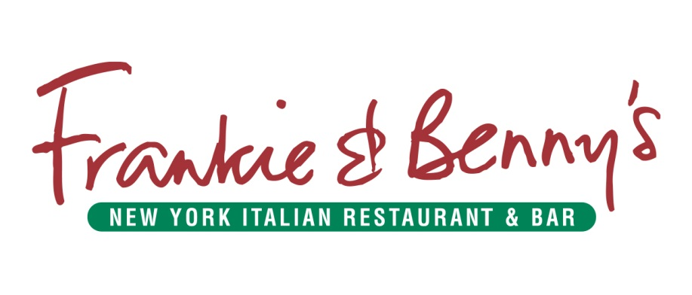

The Savoy, a Fairmont Managed Hotel, is one of the world's most iconic hotels. A renowned leader in the hospitality industry, The Savoy has a reputation for outstanding service and excellence. Originally built in 1889, the hotel has a rich history and has played host to royalty, world leaders and legends of the stage and screen. Today, colleagues pride themselves on being innovative and inspirational, delivering the very best in five star luxury. Passionate about developing and promoting talent, The Savoy offers unwavering support and recognition to colleagues, as well as having a very competitive salary & benefits plan.
Graduate & Placement opportunities for students studying: International Hospitality Management

Website address: http://www.fairmontcareers.com/

Website address: http://www.thisiscrowd.com/
Crowd is a full-service creative agency based in the United Kingdom, with offices in London, San Francisco, and Dubai. We have produced award-winning results for clients in multiple industries and from all around the globe.
In addition to web design and development, our services include strategic planning, print production, email marketing, general creative design, social media, SEO, SEM, media planning, copywriting, and TV/Radio production.
Graduate and Placement opportunities for students studying: International Hospitality Management, Events & Leisure Marketing and Tourism Management.

Working Abroad
Our customers are of all ages, come from all walks of life, and have a huge range of interests, from hiking to clubbing, skiing to surfing, lazing on the beach to soaking up some culture. Our Overseas teams are just as diverse. But they all have one thing in common; know how to put the customer first every time.
Graduate & Placement opportunities for students studying: International Hospitality Management, Events Management, Events & Leisure Marketing, Retail Management, Tourism Management, Sports Development & Coaching Sciences, Sports Management including Golf and Sports Psychology & Coaching Sciences.
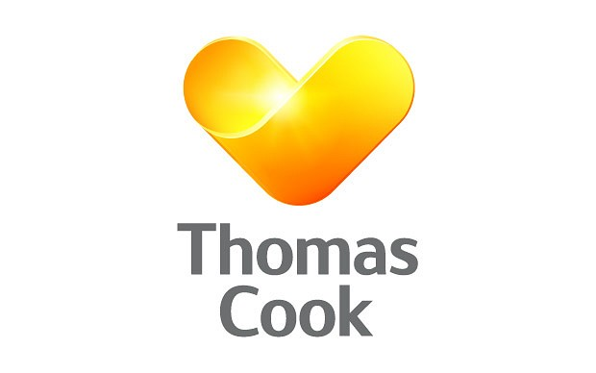

Website address: http://careers.thomascook.com/

Website address: http://www.traveltimegroup.co.uk/
The Traveltime Group is an independent, family owned travel business with eight high street branches as well as tour operators Individual Holidays and Castaways Holidays. Established in 1993 the company has grown to its current size of 30 employees and £10 million turnover. Our clientele are discerning. Our success is based on providing excellent service with a knowledgeable, friendly team. We have plans for further growth for which we need talented, committed individuals.
Graduate opportunities for students studying: Events & Leisure Marketing, Retail Management and Tourism Management.

Website address: http://www.tuitravelplc.com/careers
TUI UK & Ireland is part of the Mainstream Sector of TUI Group, one of the world’s leading international leisure travel companies, with over 240 trusted brands in 180 countries and more than 30 million customers. TUI UK & Ireland comprises many instantly recognisable brands and leading tour operators such as Thomson and First Choice, consisting of circa 650 Retail shops and the world’s largest charter airline, Thomson Airways.
The Commercial division plays a fundamental part in decision making across the TUI UK & Ireland brands. Our key aims include designing appropriate holiday and flight experiences through differentiated product channels, maximising the saleability of all our destination areas, and delivering to planned/margined targets.
We are a truly global business, employing approximately 55,000 people and operating in 31 key source markets worldwide. As a dynamic, influential company we are committed to responsible leadership in the travel sector. TUI Group is listed on the London Stock Exchange as a member of the FTSE 100 and FTSE4Good indices.
The Commercial division offers an award-wining Placement Scheme which is considered one of the best across the UK, giving you the opportunity to work in a real role, making important commercial decisions with real responsibility. We’ll be recruiting for various student jobs across the commercial division. Initially, you'll apply for a single role - Commercial Assistant - we'll then use our Assessment Centre and your preferences to work out which role would suit you best.

WHO WE ARE
Established in 1990, UK International Soccer is one of the largest providers of football education in the USA.
We work in partnership with AYSO (American Youth Soccer Association), various MLS teams, English Football Association, League Football Education (Professional Football Association) and STA Travel.
UKIS deliver high quality youth football programs for players between the ages of 4 - 18 years. We have programs in 37 States and you could be working in one or more of these.
WHO ARE WE LOOKING FOR
We are looking for qualified coaches who have experience coaching football and working with children and adults.
Applicants must be 19 years or older and have a Football Coaching qualification equivalent to an FA/SFA Level 1 or above
CONTRACTS AVAILABLE
1. 40 Week + University Placements:
2. Training programs & Summer camps:
3. Summer camps:
4. Training programs:
5. Full Time Opportunities:
Placement opportunities for students studying: Sports Development & Coaching Sciences, Sports Management including Golf, Sports Psychology & Coaching Sciences

Website address: http://uksocca.com/

The Westover Group employees 650 and is based over 28 sites in Dorset and Wiltshire. The organisation sells 14 different brand of vehicle from Land Rover to Nissan.
Vacation opportunities for students studying Retail Management, Accounting & Finance and Business Studies

Website address: http://www.westovergroup.co.uk/recruitment/

WHSmith PLC is one of the UK's leading retailers and is made up of two core businesses- Travel and High Street. WHSmith PLC is listed on the London Stock exchange and is included in the FTSE 250 index. Our goal is to be the leading retailer in convenience, books and news for the world's travelling customer and Britain's most popular high street stationer bookseller and newsagent.
Our High Street Head Office is located in Swindon, Wiltshire and our Travel Head Office is located in Holborn, London. Our Graduate Development Programme is available within various Head Office functions, such as Buying, Merchandising, Business Development, Finance, IT, Space and Format and Marketing.
Join our Head Office Graduate Development Programme and you will experience:
• Strong company leadership
• A high performance, fast paced and results driven culture
• An individual development programme
• A competitive salary and benefits package
You will quickly be accountable for a sizeable and cross-functional project, as you experience the optimum mix of on-the-job and behavioural training and receive personal guidance from outstanding industry experts, allowing you to travel far, fast!
Graduate & Placement opportunities available

Website address: http://www.whsmithcareers.co.uk/

Yummy Jobs Ltd is an international recruitment and selection company that specialises in placing young adults in work, study, volunteer and teaching experiences around the world. Yummy Jobs has developed many fantastic relationships with companies throughout the world. The Yummy Jobs Team prides itself on the level of guest service it provides to the participant and also our fantastic partners worldwide. This level of service starts from the moment you visit www.yummyjobs.com all the way through to your arrival back in your home country upon completion of your programme. The Yummy Jobs Team is constantly exploring new ways to enhance a participant's skills and experience alongside offering our partners innovative and creative ways to offer life-changing programmes. The Yummy Jobs Team is constantly exploring new ways to enhance a participant's skills and experience alongside offering our partners innovative and creative ways to offer life-changing programmes.
Graduate, Placement and summer opportunities for students studying: International Hospitality Management, Events Management and Tourism Management.

Website address: www.yummyjobs.com

